HOW TO DO PUPPET MASTER INSTALLATION

1 Clone the repository git clone https://github.com/AnjuMeleth/ DevOpsMasterPuppet.git 2 Run the Puppet Master installation script sh puppetmasterinstall.sh 3 Edit the file /etc/default/puppetserver sudo vi /etc/default/puppetserver JAVA_ARGS="-Xms512m - Xmx512m - XX:MaxPermSize=256m" 4 Open port 8140 sudo ufw allow 8140 5 Edit hosts file to enter the ipaddress of the master with a DNS name puppet sudo vi /etc/hosts 6 Start the puppetserver sudo systemctl start puppetserver

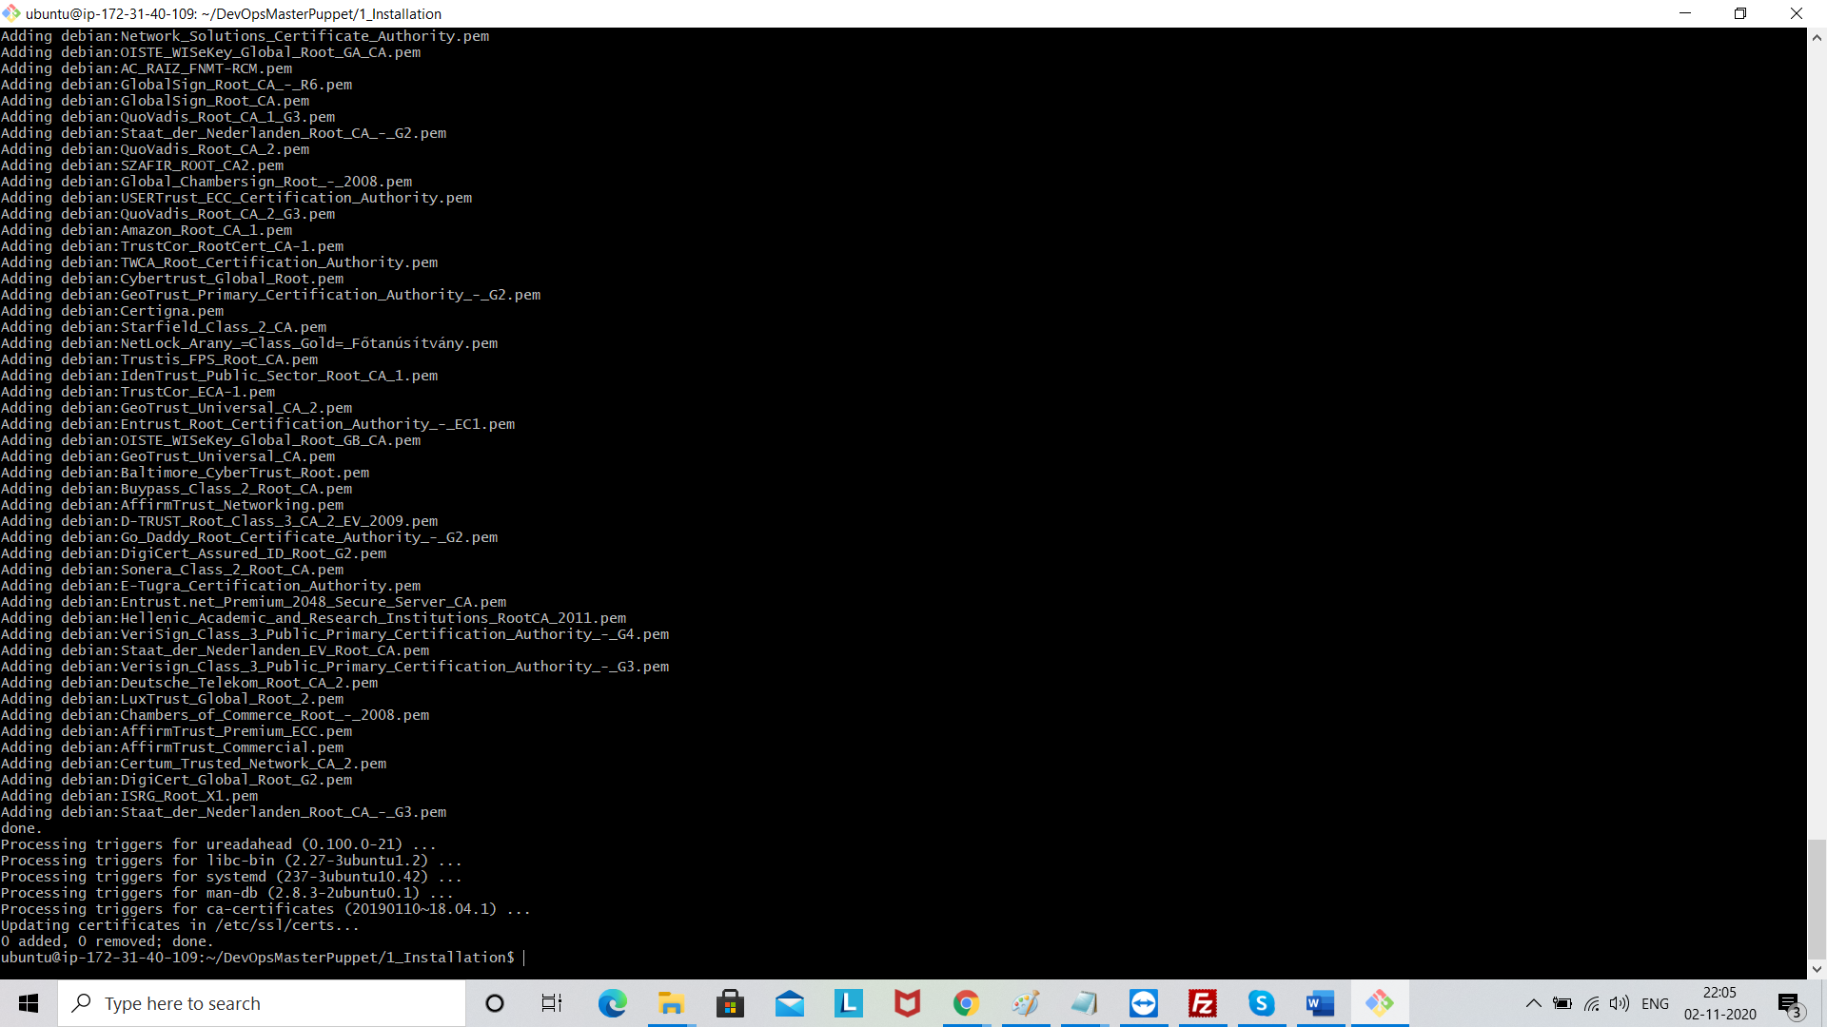

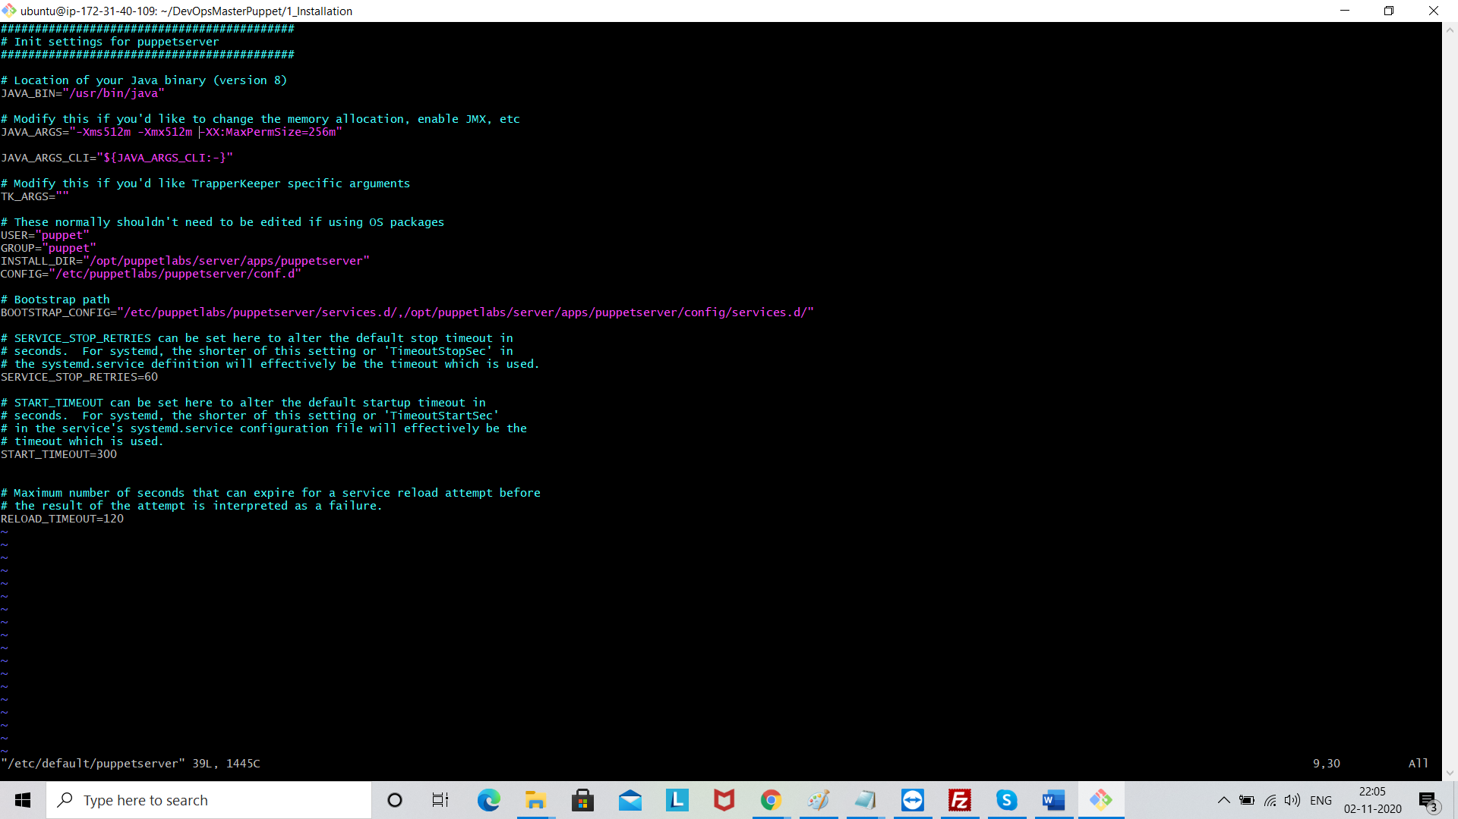

Save file wq!

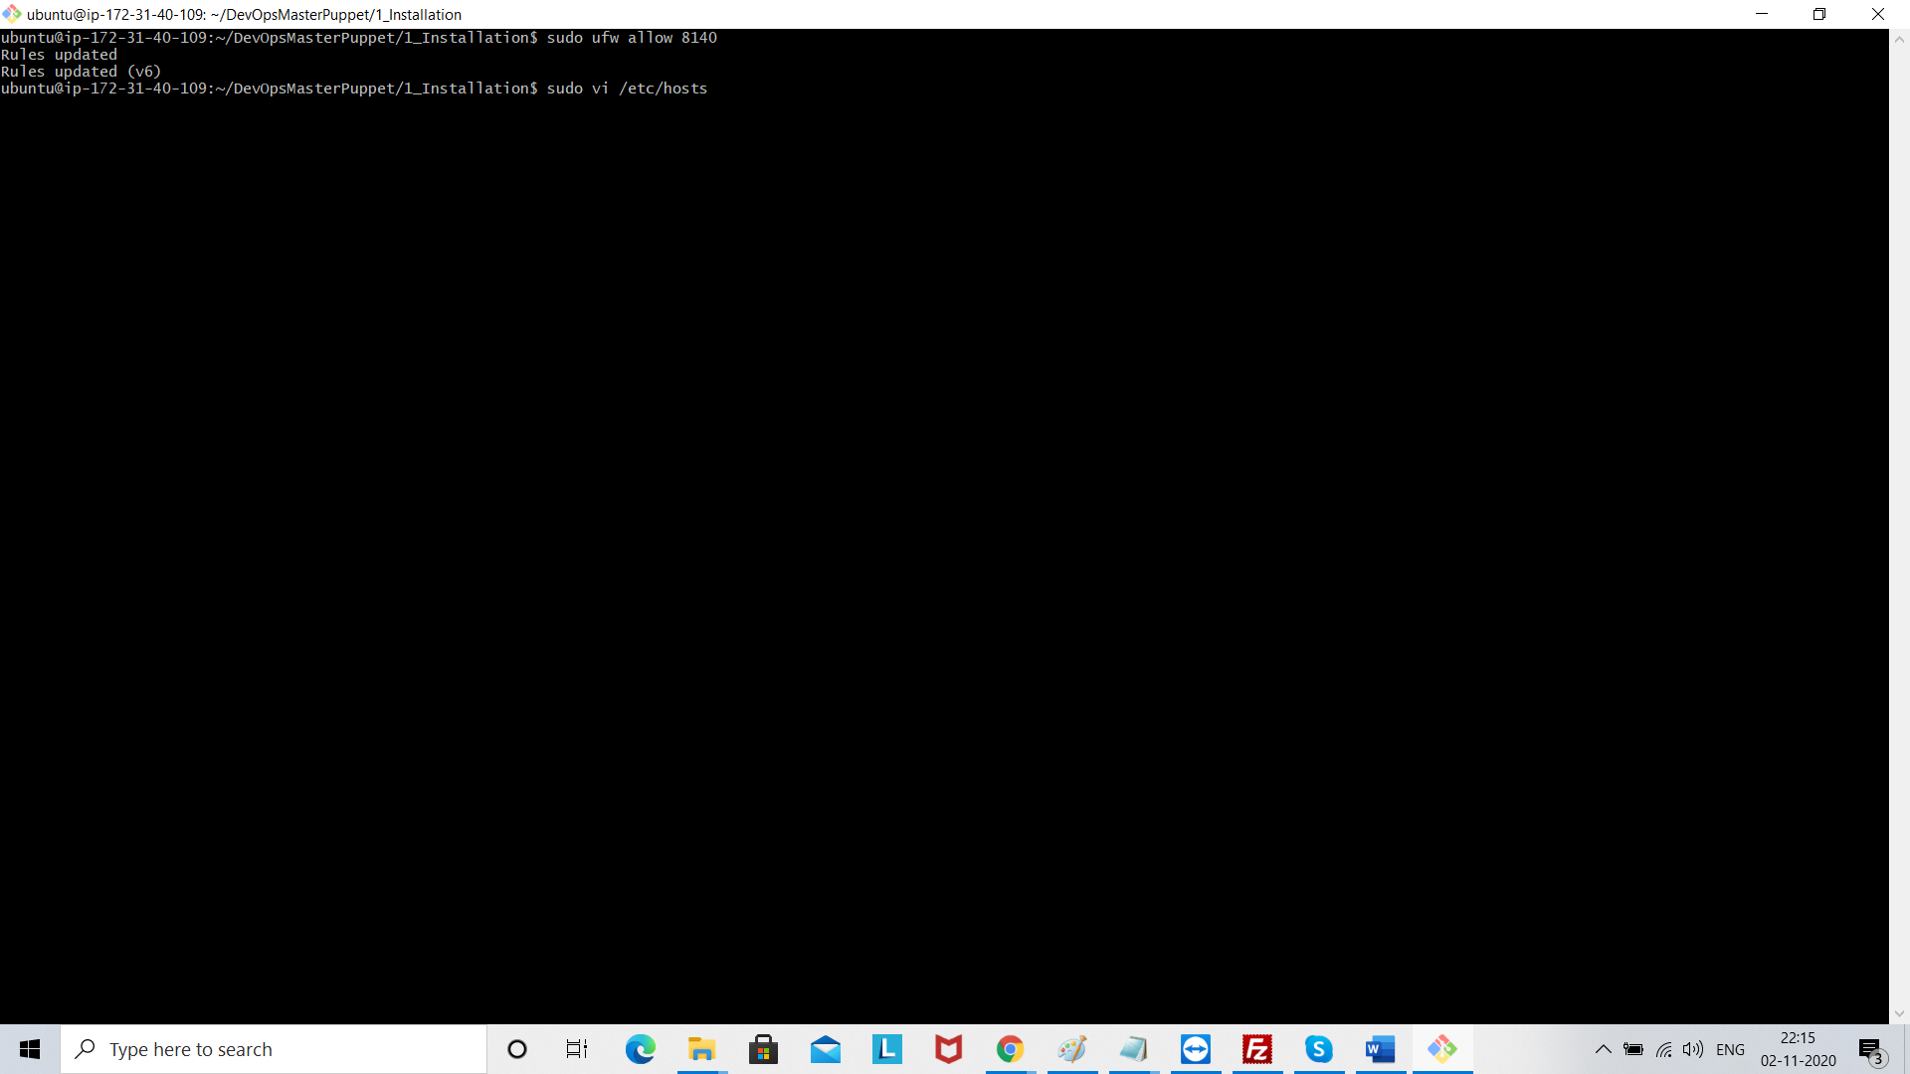

Edit hosts file to enter the ipaddress of the master with a DNS name puppet sudo vi /etc/hosts

Enter the ip address of master (node 1)

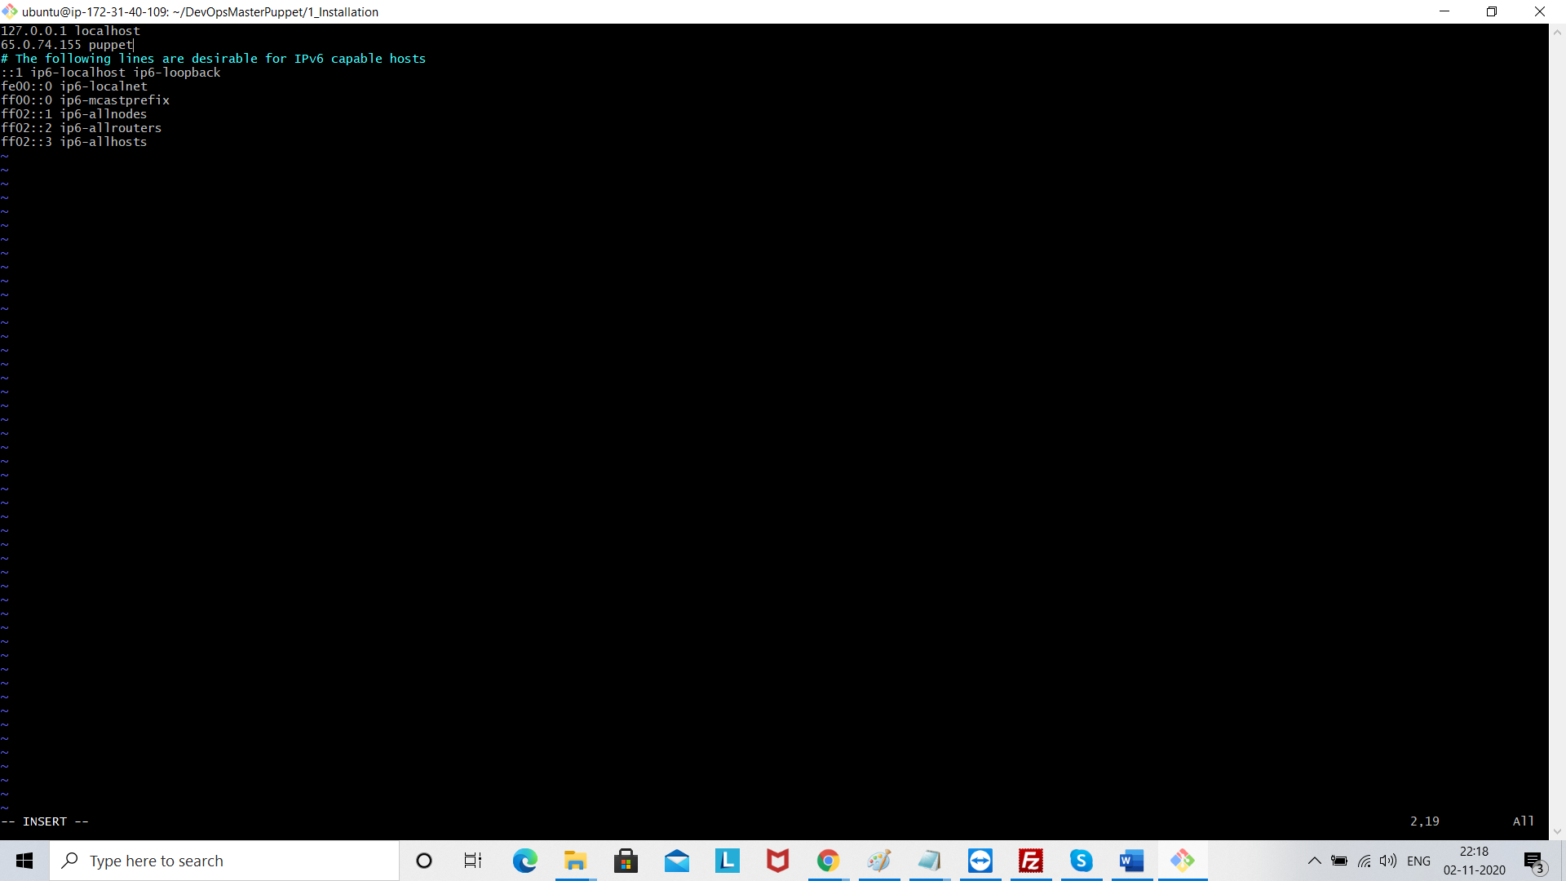

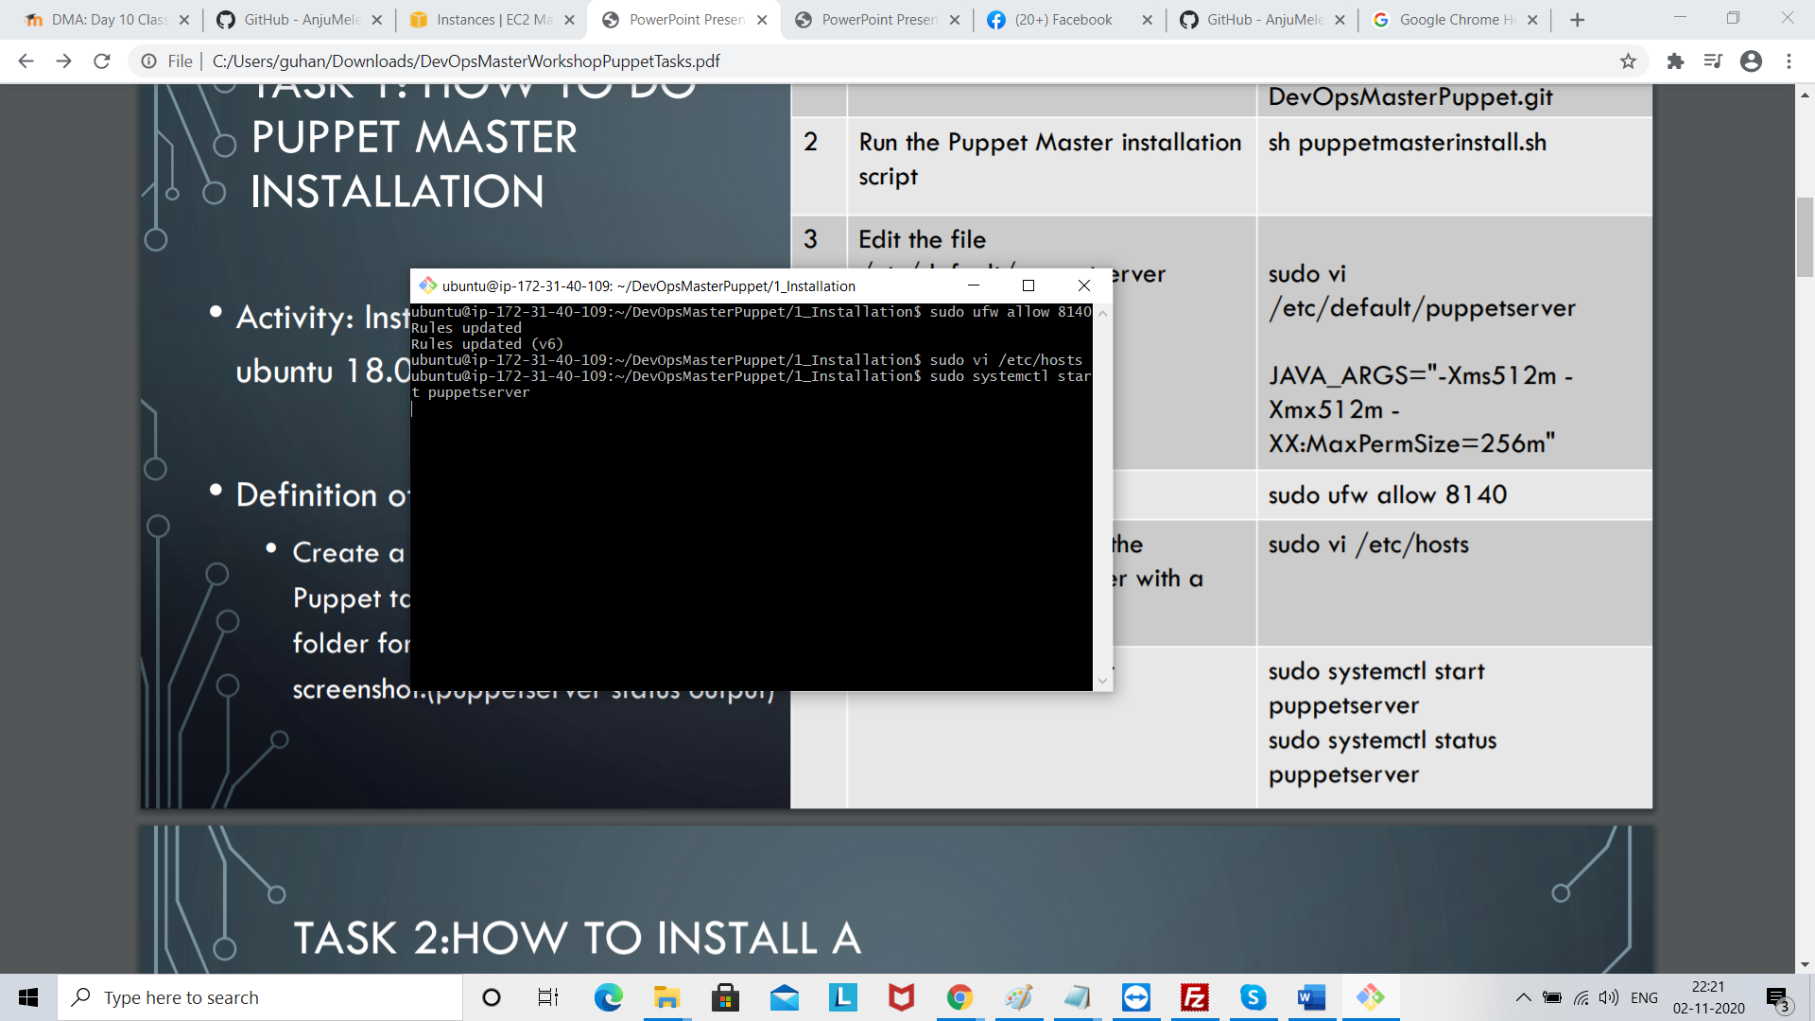

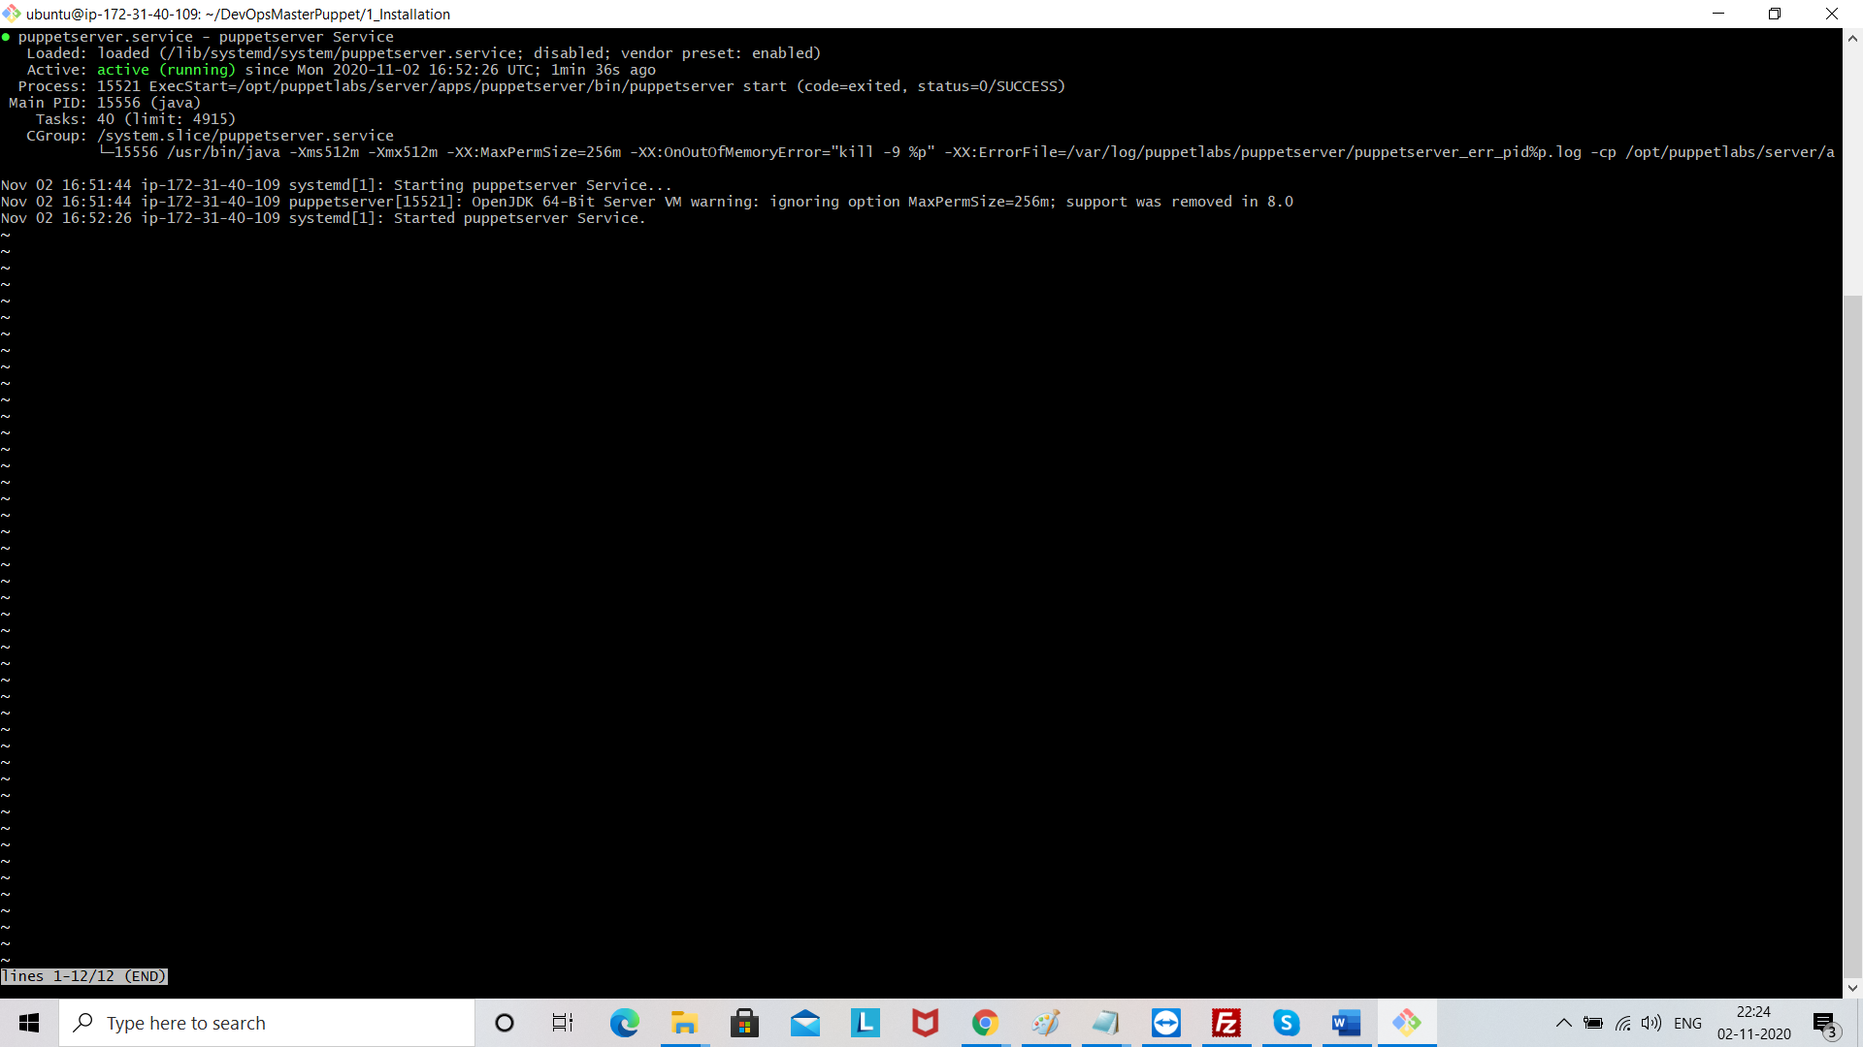

Come out by clicking Ctr + c